3
3RD AMERICAS FORUM
RD
October 23 - 24, 2024 I Plymouth (MI)
CALL - FOR - SPEAKERS

22000
ABOUT CARES
CARES is a two - day conference highlighting the innovative techniques and strategies used in sustainable automotive manufacturing. Held in Plymouth (MI), the 2024 CARES Americas Event will have keynote presentations, theme-oriented discussions, educational workshops, and networking events with car manufacturers and environmental experts.
In its 3rd year in 2024, the transdisciplinary forum expects to host 300+ professional attendees ranging from automotive professionals and sustainability advocates.
The goal is to inspire industry professionals to advance green automotive manufacturing practices, cross-sector, industry, and expertise collaboration. CARES is the premier platform for attendees to learn and discuss innovative strategies, leading technologies, and new business opportunities related to sustainable manufacturing in the automotive industry.
2023 CARES AMERICAS OVERVIEW
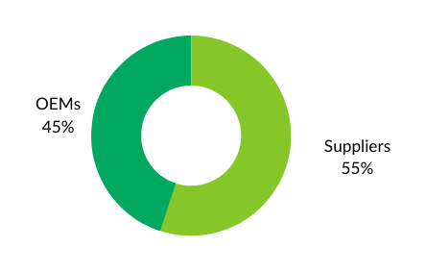
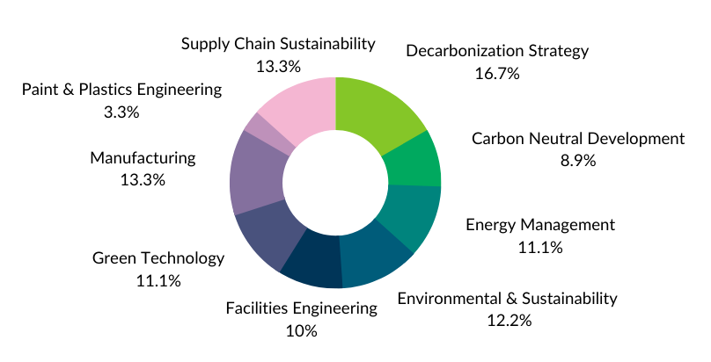
PARTICIPANTS DEMOGRAPHICS
2023 WINNING PRESENTATIONS

- OEM Attendees Department
- Participating Companies

AWARD FOR INNOVATION​
Recycled NCM cathode active material engineered for high-power, high-performance lithium-ion battery applications​s - ASCEND ELEMENTS & XAL ENERGY
AWARD FOR TECHNIQUE
Toyota Approach to Carbon Neutrality - TOYOTA MOTOR MANUFACTURING
​JURY’S AWARD
Engineering New Carbon-Negative Plastic Materials for the Automotive Industry - MAGNA EXTERIORS & HEARTLAND INDUSTRIES
​THE AUDIENCE CHOICE AWARD
Cradle to Grave Carbon Footprint of Automotive coatings, adhesives, and sealants materials​ - PPG
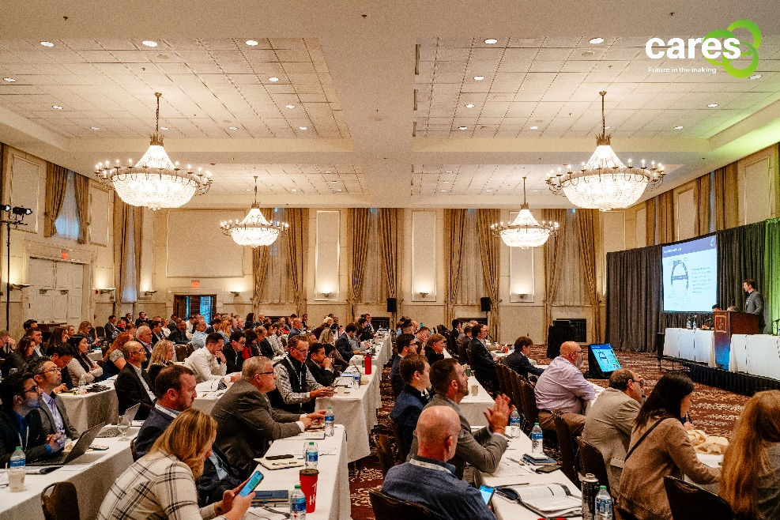

2024 TECHNICAL THEMES
Your company has something unique and powerful to share with automotive professionals and sustainability advocates? We are seeking dynamic speakers who are passionate about their topics, have inspiring real industry experience to share and can captivate an audience.
At CARES 2024, we will delve into the critical challenges and driving forces shaping our industry. The following suggested topics will serve as focal points for our discussions:
- Practical carbon footprint reduction measures:
- What are concrete and practical strategies that Car Manufactures can take to minimize their carbon footprint, devoid of promotional or self-promotional elements?
- Delving into the Environmental Impact of Batteries and Paint:
- What are the best practices and case studies that exemplify successful advancements in recyclability, circular economy integration, and carbon neutrality?
- What are the critical metrics for assessing the effectiveness of recyclability, circular economy integration, and carbon neutrality initiatives?
- OEM sourcing strategies for sustainability
- How can OEMs effectively align their sourcing strategies with the dual objectives of minimizing product carbon footprints (PCFs) and promoting the adoption of circular products?
- Sustainable Automotive Component Recycling:
- How can OEMs identify and collaborate with companies that specialize in sorting and recycling automotive components?
- Challenges and Opportunities of Sustainable Materials Integration:
- How can OEMs and suppliers use new materials (mastic materials, low bakes adhesive, low bake e-coats) with lower carbon footprint and how can we ensure that recycled materials are accepted by OEMs specifications.
- How to consider these changes in brownfield plants and plants processing multiple different materials and models?
- Design for remanufacturing:
- What are the obstacles to remanufacture? What things shouldn’t we use? What should be eliminated? What of this can we reuse.
- Waste management solutions:
- What innovative approaches are emerging companies and technologies pioneering to transform waste management and promote sustainable resource utilization?

- ESG and corporate sustainability:
- How is the growing focus on ESG (environmental, social, and governance) impacting business strategies and decision-making across industries?
- Utility sector and regulatory influences:
- To what extent are automotive manufacturers and suppliers collaborating with utilities to drive the transition towards a more sustainable transportation future, and how do regulatory frameworks support or hinder this transition?
- Renewable energy and supply chain decarbonization:
- How can automotive industry stakeholders effectively assess the progress and impact of their renewable energy integration, supply chain decarbonization, and Scope 3 emissions reduction efforts, ensuring continuous improvement and sustainability?
- Quantifying OEM carbon footprint reductions:
- How can we create a standardized framework for data collection and analysis to enable consistent and comparable assessment of carbon footprint reductions by OEMs?
- Nature-based solutions and water management:
- To what extent can nature-based solutions, including water stewardship practices, influence life cycle assessments (LCAs) and provide a more holistic understanding of the environmental impact of products?
- Supplier innovation and cost considerations:
- How can we effectively assess and address the potential financial barriers that suppliers may face in adopting innovative solutions for carbon emission reduction?"
- What are the existing financing models or incentives that can be leveraged to support suppliers' investments in carbon emission reduction innovations?"

Before you submit, what you need to know about:
HOW ARE THE PAPERS SELECTED?
Papers are evaluated and assembled by a high-level International Committee composed of major OEMs and suppliers. Using the information in the form you will have filled in below; they will assess its industrial relevance and contribution to the industry. It is therefore crucial for your form to be filled in with key details in each section. Focus will be on tests results, figures, applicability, and benefits.
Preference will be given to detailed technical papers on:
- Joint presentations between the OEM and Supplier
- First-hand presentation
- Real life industrial experience sharing
- Focus on Technical innovation.
- Follow-up from previous CARES Congress presentations
- Interesting papers refused because of agenda at previous CARES.
The committee reminds you the presentations should be technical than purely Commercial presentations.
BENEFITS OF BEING CARES SPEAKERS
Being a speaker at CARES Conference is an excellent way to gain visibility for your company solutions and business expertise. This allows you to share your knowledge and expertise with a wider audience, establishing yourself as a thought leader in your field. This can significantly enhance your credibility and reputation within the industry, opening doors to new opportunities and collaborations.
Speaking engagements also gives the presenting companies a platform to spread the word about company’s products, services and reach a global audience of decision-makers and experts in automotive manufacturing companies (car manufacturers, OEM powertrain, OEM final assembly suppliers, raw material suppliers, energy suppliers, battery producers, battery recycler, waste management, water, energy management experts, data management, etc.) from around the world.
By presenting a topic at CARES, you are eligible to receive a CARES Award! At the end of the two-day conference, the CARES committee will reward the best presentations in different categories.
- The Award for Innovation
- The Award for Technique
- The Jury’s Award
- The Audience Choice Award
ONLY 25 Presentations will have the opportunity to be shared at CARES. So please be aware that many high-quality proposals may regretfully have to be declined.

SESSION FORMAT
- Joint Presentation (between OEM and Suppliers) will have 25 minutes to present their contribution (preferred) and 5-min question & answer session with Session Chairpersons and audience.
- A single speaker will have 15 minutes to present, plus an additional 5-min Q&A.

SPEAKER REGISTRATION FEE: USD 1150
Registration fee includes the two-day conference, break-out sessions, refreshment break, lunch, gala dinner, awards ceremony. The registration fee does not include travel expenses, parking fees or any other additional cost or service.

QUESTIONS TO CONSIDER BEFORE SUBMITTING YOUR PROPOSAL
In submitting a paper, you agree to register and pay the presenter fees to CARES and make yourself available to present it at any slot that the committee chooses.
SUBMISSION DATE: Fri 16/02/2024
To: bin.wu@infopro-digital.com

2024 SUBMISSION FORM
All fields are Compulsory.
Contact person in charge of the submission
Company Name:
Surname:
Name:
Job title:
Email:
Office phone number:
Mobile number
Company location:
Zip code & State:
Country:

Speaker(s) contact details
Contact details | Speaker | Joint Speaker (if different company)
Company Name
Surname
Name
Job title
Mobile number
Email
Company location City & State

Has this paper already been presented at other professional events? *
£ No
£ Yes, if yes, please specify which event and when *: ___________________________________________
SUBMISSION DATE: Fri 16/02/2024
To: bin.wu@infopro-digital.com
PRESENTATION ABSTRACT
CARES Committee will evaluate your below abstract and decide if the topics and contents are a good fit for 2024 CARES conference. Please send us the abstract on due time for Committee Technical Paper Review. If selected, your final presentation will be needed 4 weeks before the event day.
To help us seamlessly integrate your presentation into the program, we kindly request that you align your content proposal with one of the following categories and suggested topics.
If your content proposal doesn't fit neatly into any of these categories, feel free to apply anyway. The CARES Committee will consider your proposal for inclusion if it demonstrates significant value to sustainable automotive manufacturing.

THEME CATEGORIES
MAIN CATEGORIES |  | SUGGESTED TOPICS | Your choice
Category 1:  Practical Carbon Footprint Reduction Measures | What concrete and practical strategies can car manufacturers implement to minimize their carbon footprint (not including greenwashing, carbon offset…) |  | £
 | What are the best practices and case studies that show successful advances in recyclability, circular economy integration, and carbon neutrality? |  | £
 | What are the critical metrics/benchmarks to evaluate the effectiveness of recyclability, circular economy integration, and carbon neutrality initiatives? |  | £
Category 2:  OEM Sourcing Strategies for Sustainability | How can OEMs effectively align their sourcing strategies to minimize product carbon footprints (PCFs) and promote the adoption of circular products? |  | £
 | How can OEMs identify and collaborate with companies that specialize in sorting and recycling automotive components? |  | £
Category 3:  Sustainable Materials Integration | How can OEMs and suppliers utilize new materials (mastic materials, low bake adhesive, low bake e-coats) with lower carbon footprints, and how can they ensure that recycled materials meet OEM specifications? |  | £
 | How can these changes to integrate sustainable materials be undertaken in brownfield plants and plants processing multiple different materials and models |  | £

MAIN CATEGORIES | SUGGESTED TOPICS | Your choice
Category 4:  Design for circular economy and Waste Management Solutions | What are the obstacles to remanufacture, and what materials should be avoided, eliminated, or reused to facilitate circular economy? | £
 | What innovative approaches are emerging companies and technologies pioneering to transform waste management and promote sustainable resource utilization? | £
 | How is the growing focus on ESG (environmental, social, and governance) impacting business strategies and decision-making across industries? | £
 | To what extent are automotive manufacturers and suppliers collaborating with utilities to drive the transition towards a more sustainable transportation future, and how do regulatory frameworks support or hinder this transition? | £
 | How can automotive industry stakeholders effectively assess the progress and impact of their renewable energy integration, supply chain decarbonization, and Scope 3 emissions reduction efforts, ensuring continuous improvement and sustainability? | £
 | How can we create a standardized framework for data collection and analysis to enable consistent and comparable assessment of carbon footprint reductions by OEMs? | £
 | To what extent can nature-based solutions, including water stewardship practices, influence life cycle assessments (LCAs) and provide a more holistic understanding of the environmental impact of products? | £
 | How can we effectively assess and address the potential financial barriers that suppliers may face in adopting innovative solutions for carbon emission reduction? | £
 | What are the existing financing models or incentives that can be leveraged to support suppliers' investments in carbon emission reduction innovations? | £

SUBMISSION DATE: Fri 16/02/2024
To: bin.wu@infopro-digital.com

PRESENTATION ABSTRACTS
PRESENTATIONT TITLE

TO BE COMPLETED

CONTENT ABSTRACTS

Suggested structures/questions to cover in your proposals:
- INDUSTRY OVERALL CONTEXT
- TECHNICAL SPECIFICATIONS
- PERFORMANCE & RESULTS
- INDUSTRY USER EXPERIENCE
TO BE COMPLETED

