3
RD

22000
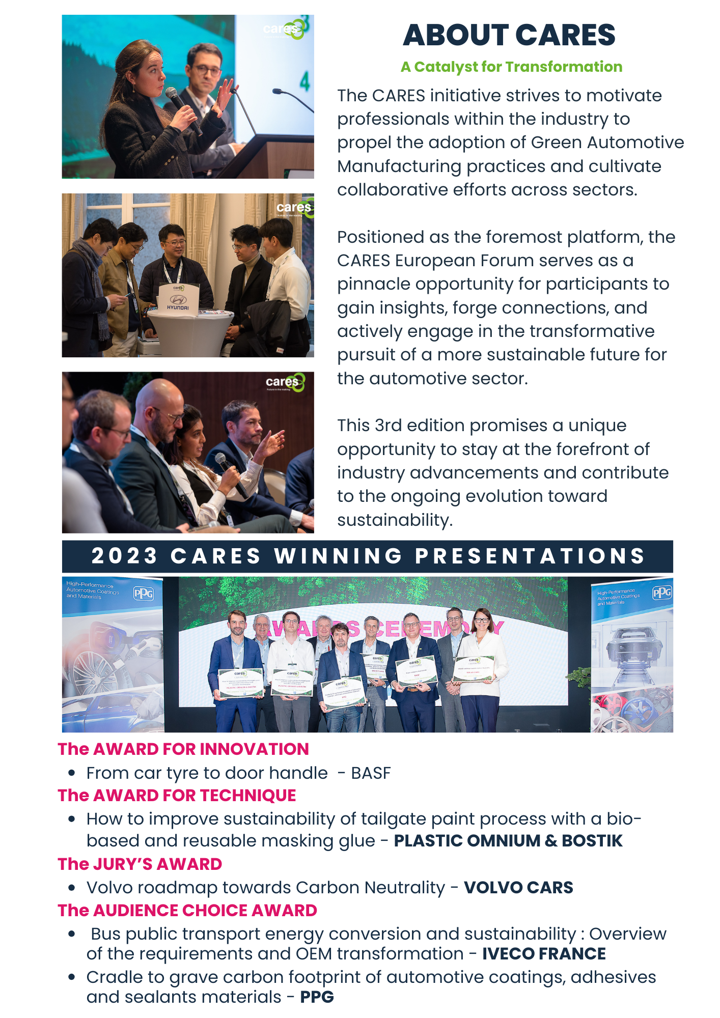
Call for Dynamic Speakers at CARES 2024
Do you represent a company with a unique and impactful perspective that can resonate with automotive professionals and sustainability advocates? We are on the lookout for dynamic speakers who are not only passionate about their topics but also bring inspiring real industry experience to the table, capable of captivating our discerning audience.
CARES 2024 is set to be a platform where we delve into the critical challenges and driving forces shaping our industry's future.
We invite speakers to propose presentations that align with our theme. While we welcome diverse topics, the following suggested areas will serve as focal points for our discussions:
- Carbon Footprint Reduction in European Mobility Manufacturing and Engineering:
  - Strategies for European car manufacturers to minimize carbon footprints, emphasizing practical and non-promotional actions.
- Environmental Impact of Batteries and Paint in Europe:
  - Best practices and case studies on recyclability, circular economy integration, and carbon neutrality in the European automotive market.
  - Identification of critical metrics for evaluating the effectiveness of these initiatives in Europe
- Recirculation of Automotive Parts and Used-Cars in Europe:
  - Successful collaboration - case studies of Automotive OEMs with specialized companies in sorting and recycling automotive Parts.
  - Design for Remanufacturing: Identification of obstacles to remanufacturing specific to the European Automotive market and how to resolve these obstacles.
- Challenges and Opportunities of Sustainable Materials Integration in manufacturing
  - Exploration of new materials with lower carbon footprints in manufacturing process
  - Alignment of sourcing strategies by European OEMs with objectives to reduce product carbon footprints and promote circular products.
  - Addressing acceptance of recycled materials by OEMs, considering specifications and changes in brownfield plants.
- Waste Management Solutions in the Automotive production Sector:
  - Highlighting innovative approaches from emerging European companies and technologies for sustainable waste management.
- How European automotive stakeholders can integrate renewable energy in production and decarbonize supply chains.
- Standardized Frameworks for Quantifying OEM Carbon Footprint Reductions in Europe:
  - Development of standardized frameworks for data collection and analysis to assess carbon footprint reductions by European OEMs consistently.
- Innovative soft sectors to incorporate to achieve sustainable manufacturing.
  - Digitalization & Smart manufacturing
  - AI-driven algorithms can be applied to optimize production processes, to improve energy efficiency, waste reduction, and better utilize resources.
  - Regulations: how industry stakeholders can collaborate with authorities to develop and update regulations, to ensure that regulations are realistic, feasible, and consider the latest advancements in sustainable manufacturing technologies.
  - Green Finance: Assessment of financial barriers faced by suppliers in adopting carbon emission reduction innovations, accessing green financing options can provide capital for sustainable initiatives.

Before you submit, what you need to know about:
HOW ARE THE PAPERS SELECTED?
Papers are evaluated and assembled by a high-level International Committee composed of major OEMs and suppliers. Using the information in the form you will have filled in below, they will assess its industrial relevance and contribution to the industry. It is therefore crucial for your form to be filled in with key details in each section. Focus will be on tests results, figures, applicability, and benefits.
Preference will be given to detailed technical papers on:
- Joint presentations between the OEM and Supplier
- First-hand presentation
- Real life industrial experience sharing
- Focus on Technical innovation.
- Follow-up from previous CARES Congress presentations
- Interesting papers refused because of agenda at previous CARES.
The committee reminds you the presentations should be technical than purely Commercial presentations.
BENEFITS OF BEING CARES SPEAKERS
Being a speaker at the CARES Conference is an excellent way to gain visibility for your company solutions and business expertise. This allows you to share your knowledge and expertise with a wider audience, establishing yourself as a thought leader in your field. This can significantly enhance your credibility and reputation within the industry, opening doors to new opportunities and collaborations.
Speaking engagements also gives the presenting companies a platform to spread the word about company’s products, services and reach a global audience of decision-makers and experts in automotive manufacturing companies (car manufacturers, OEM powertrain, OEM final assembly suppliers, raw material suppliers, energy suppliers, battery producers, battery recycler, waste management, water, energy management experts, data management, etc.) from around the world.
By presenting a topic at CARES, you are eligible to receive a CARES Award! At the end of the two-day conference, the CARES committee will reward the best presentations in different categories.
- The Award for Innovation
- The Award for Technique
- The Jury’s Award
- The Audience Choice Award
ONLY 25 Presentations will have the opportunity to be shared at CARES. So please be aware that many high-quality proposals may regretfully have to be declined.
SESSION FORMAT
- Joint Presentation (between OEM and Suppliers) will have 25 minutes to present their contribution (preferred) and 5-min question & answer session with Session Chairpersons and audience.
- A single speaker will have 15 minutes to present, plus an additional 5-min Q&A.
SPEAKER REGISTRATION FEE: EUR 1150
Registration fee includes the two-day conference, break-out sessions, refreshment break, lunch, gala dinner, awards ceremony. The registration fee does not include travel expenses, parking fees or any other additional cost or service. In submitting a paper, you agree to register and pay the presenter fees to CARES and make yourself available to present it at any slot that the committee chooses.

2024 SUBMISSION FORM
All fields are Compulsory.
Contact person in charge of the submission
Company Name:
Surname: ……………………………………………………….
Name: ……………………………………………………….
Job title: ……………………………………………………….
Email: ……………………………………………………….
Office phone number: ……………………………………………………….
Mobile number: ……………………………………………………….
Company location: ……………………………………………………….
Zip code & State: ……………………………………………………….
Country: ……………………………………………………….

Speaker(s) contact details
Contact details | Speaker | Joint Speaker (different company ONLY)
Company Name
Surname
Name
Job title
Mobile number
Email
Company location City & State

Has this paper already been presented at other professional events? *
£ No
£ Yes, if yes, please specify which event and when *: ___________________________________________
SUBMISSION DATE: Monday 22/04/2024
To: irene.cavalazzi@infopro-digital.com
PRESENTATION ABSTRACT
CARES Committee will evaluate your below abstract and decide if the topics and contents are a good fit for 2024 CARES conference. Please send us the abstract on due time for Committee Technical Paper Review. If selected, your final presentation will be needed 4 weeks before the event day.
To help us seamlessly integrate your presentation into the program, we kindly request that you align your content proposal with one of the following categories and suggested topics.
If your content proposal doesn't fit neatly into any of these categories, feel free to apply anyway. The CARES Committee will consider your proposal for inclusion if it demonstrates significant value to sustainable automotive manufacturing.
THEME CATEGORIES
MAIN CATEGORIES | SUGGESTED TOPICS |  | Your choice
Category 1:  Environmental Impact and Carbon Footprint Reduction |  | Carbon Footprint Reduction in European Mobility Manufacturing & Engineering | £
 |  | Environmental Impact of Batteries and Paint in Europe | £
 |  | How European automotive stakeholders can integrate renewable energy in production and decarbonize supply chains. | £
 |  | Standardized Frameworks for Quantifying OEM Carbon Footprint Reductions in Europe.
Category 2:  Circular Economy and Recirculation |  | Spare – Parts Recirculation | £
 |  | Waste Management Solutions in Automotive production | £
 |  | Used – Vehicles Recirculation
 |  | Trends to readapt ICE cars
Category 3:  Materials Sustainability and Design |  | Challenges and Opportunities of Sustainable Materials Integration in manufacturing. | £
 |  | Design for Remanufacturing | £
Category 4:  Innovative soft sectors to incorporate to achieve sustainable manufacturing |  | Innovation and Financing models to achieve sustainable manufacturing. | £

PRESENTATION ABSTRACTS
PRESENTATIONT TITLE

TO BE COMPLETED

CONTENT ABSTRACTS

Suggested structures/questions to cover in your proposals:
- INDUSTRY OVERALL CONTEXT
- TECHNICAL SPECIFICATIONS
- PERFORMANCE & RESULTS
- INDUSTRY USER EXPERIENCE
TO BE COMPLETED

