2
ND
EUROPEAN CONFERENCE
8 – 9 November 2023 _{(subject to change)}
CALL-FOR-SPEAKERS
Your company has something unique and powerful
to share with automotive professionals and
sustainability advocates?
Join 2023 CARES Speaker lineup!
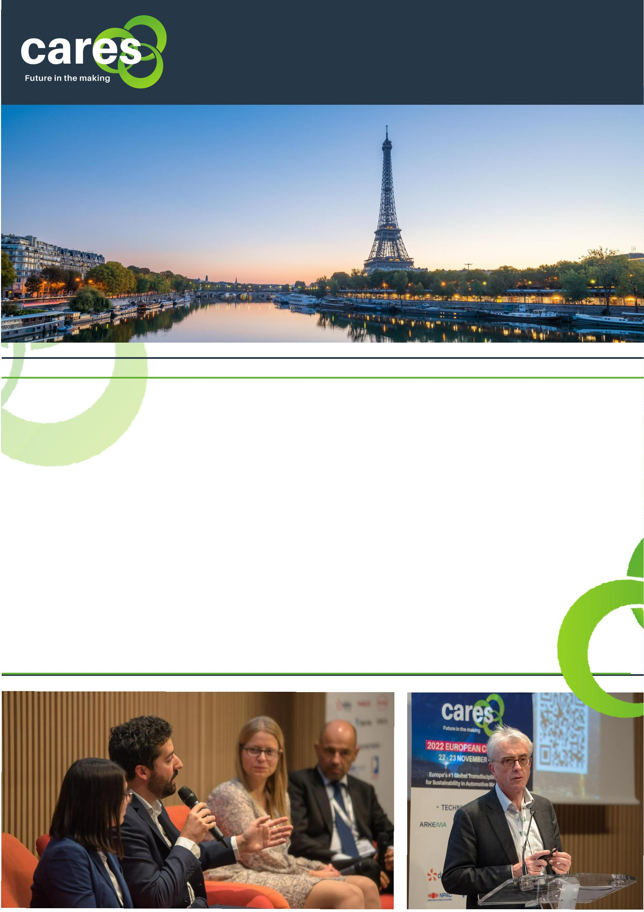

2
ND
EUROPEAN CONFERENCE
8 - 9, November 2023 _{(SUBJECT TO CHANGE)}
CARES is a two - day conference
highlighting the innovative
techniques and strategies used in
sustainable automotive
manufacturing. Held in Paris France,
the CARES European Forum will have
keynote presentations, theme-
oriented discussions, educational
workshops, and networking events
with car manufacturers and
cares-sustainableforum.com
2022 CARES DEMOGRAPHICS
environmental experts.
0
1. ATTENDEE TYPE
In its second year in 2023, the
transdisciplinary forum expects to
host 400+ professional attendees
ranging from automotive
professionals and sustainability
advocates.
OEMs
30%
Suppliers
70%
02. JOB LEVEL
Vice President
8
%
Director
29%
Executive Management
8%
1
Our goal is to inspire industry
professionals to advance green
automotive manufacturing
Board
5%
Manager
40%
practices, cross-sector and industry
collaboration. CARES is the premier
platform for attendees to learn and
discuss innovative strategies,
leading technologies, and new
business opportunities related to
sustainable manufacturing.
0
3. OEM ATTENDEES DEPARTMENT
Supply Chain Sustainability
12%
Carbon Neutral Development
8
%
Paint & Plastics Engineering
0%
Energy Management
10%
2
Environmental & Sustainability
11%
Manufacturing
5%
Facilities Engineering
1
9%
2022 CARES ATTENDEES FEEDBACK
95%
96%
223
Attendees would like to join in next CARES Congress.
Attendees would recommend CARES to their colleagues and friends.
Numbers of questions that Attendees asked to presenters and panelists
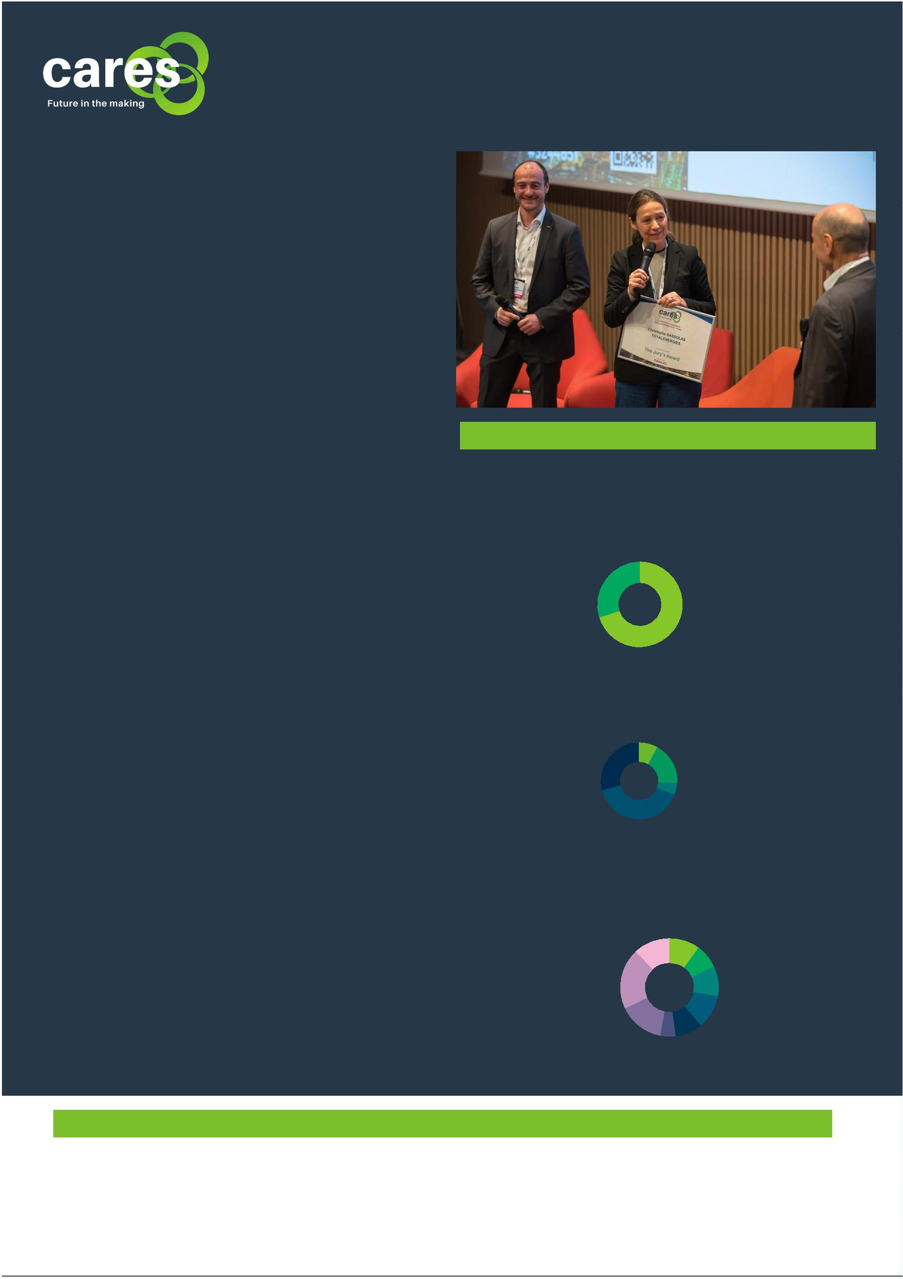
8- 9 – 10, November 2023 (SUBJECT TO CHANGE)
8 – 9 – 10 November 2023 (SUBJECT TO CHANGE)

2
ND
2023 TECHNICAL THEMES
Sustainability has become the priority in Automotive companies’ production processes.
By focusing on reducing the environmental impact of their production operations, reducing waste,
utilizing more sustainable materials, and researching and developing new green technologies for
production, automotive manufacturers will be in a strong position to remain competitive in the
years to come.
Your company has something unique and powerful to share with automotive professionals and
sustainability advocates? We are seeking dynamic speakers who are passionate about their topics,
have inspiring real industry experience to share and can captivate an audience.
At CARES 2023, we address two main categories subjects:
Automotive OEMs strategy and needs to achieve sustainable production
We wish actively address the OEMs' current needs at this 2023 edition: the current status of OEMs'
sustainability implementation regarding the production - where is the industry today, and also
what are Auto OEMs' goals to sustainability - where do OEMs want to go, which return on invest is
acceptable for Auto OEMs.
Resource Sustainability
This can include ways to develop alternative more sustainable sources for the raw materials used in
car manufacturing, implement renewable and recyclable materials (zero-carbon steel, carbon fiber
materials, soy, wheat...), reduce waste materials that are produced during the production process…
all means that can reduce fuel consumption as well as emissions throughout production.
Resource sustainability category aims to identify ways to further reduce the amount of energy
used, including renewable sources, improving the overall energy efficiency of automotive
production, and implementing smart energy management systems throughout their production
processes.
We look for companies who will demonstrate efficient production methods, design for durability
and recyclability, including developing closed-loop battery technology by reusing batteries and
recycling the metals.
Data Empowerment
Data is increasingly important in helping to ensure the sustainability of automotive manufacturing
and determinate the ROI of sustainability initiatives.
Data Empowerment aims to identify data-driven approaches solutions which allow for information
to be gathered about the use of various resources, such as materials, energy, and water, which can
then be analyzed and acted upon. This could include services and solutions which provide quality,
comparable and transparent data of the emissions produced by suppliers and other parts of the
supply chain. By understanding how emissions are generated and whether they are increasing or
decreasing, automotive manufacturers can work on reducing emissions more efficiently.
Finally, data is an asset when it comes to measuring the return on investment of sustainability
initiatives in automotive manufacturing. At CARES 2023, we look for presentations about solutions
and tools to determine the impact of Auto manufacturers’ programs and initiatives in terms of
factors such as cost savings, efficiency gains, and environmental performance.
8- 9 – 10, November 2023 (SUBJECT TO CHANGE)

2
ND
EUROPEAN CONFERENCE
8 – 9 – 10 November 2023 (SUBJECT TO CHANGE)
PRACTICAL INFORMATION
HOW ARE THE PAPERS SELECTED?
Papers are evaluated and assembled by a high-level International Committee composed of major
OEMs and suppliers. Using the information in the form you will have filled in below, they will assess
its industrial relevance and contribution to the industry. It is therefore crucial for your form to be
filled in with key details in each section. Focus will be on tests results, figures, applicability, and
benefits.
Preference will be given to detailed technical papers on:
Joint presentations between the OEM and Supplier
First-hand presentation
Real life industrial experience sharing
Focus on Technical innovation
Follow-up from previous CARES Congress presentations
Interesting papers refused because of agenda at previous CARES
The committee reminds you the presentations should be technical than purely
Commercial presentations.
BENEFITS OF BEING CARES SPEAKERS
Being a speaker at CARES Conference is an excellent way to gain visibility for your company
solutions and business expertise. You can use the opportunities to raise awareness of your
company, build credibility with your peers and provide invaluable networking opportunities.
Speaking engagements also gives the presenting companies a platform to spread the word about
company’s products, services and reach a global audience of decision-makers and experts in
automotive manufacturing companies (car manufacturers, OEM powertrain, OEM final assembly
suppliers, raw material suppliers, energy suppliers, battery producers, battery recycler, waste
management, water, energy management experts, data management, etc.) from around the
world.
By presenting a topic at CARES, you are eligible to a CARES Award! At the end of the two-day
conference, the CARES committee will reward the best presentations at different categories.
ONLY 20 Presentations will have the opportunity to be shared at CARES. So please be aware that
many high-quality proposals may regretfully have to be declined.
SESSION FORMAT
Joint Presentation (between OEM and Suppliers) will have 25 minutes to present their
contribution (preferred) and 5-min question & answer session with Session Chairpersons and
audience.
A single speaker will have 15 minutes to present, plus additional 5-min Q&A.
QUESTIONS TO CONSIDER BEFORE SUBMITTING YOUR PROPOSAL
In submitting a paper, you agree to register to CARES and make yourself available to present it
at any slot that the committee chooses.
Speaker Registration Fee: EUR 550*.
*
Registration fee includes the two-day conference, break-out sessions, refreshment break, lunch, gala diner, awards ceremony. The registration fee does
not include travel expenses, parking fees or any other additional cost or service.

SUBMISSION FORM

2
ND
SUBMISSION DATE: FRI 30/06/2023
To: bin.wu@infopro-digital.com
Company Name
Contact Person for Submission
Name
Job Title
Phone number
Business Email
Speaker's contact details
Company name
Name
Job Title
Phone number
Business Email
Joint Speaker's contact details if any
Company name
Name
Job Title
Phone number
Business Email
Has this paper already been presented at other professional events?

NO YES (IF YES, PLEASE SPECIFY WHICH EVENT AND WHEN):
___________________________________________________________________________

2
ND
EUROPEAN CONFERENCE
8 – 9 – 10 November 2023 (SUBJECT TO CHANGE)
PRESENTATION ABSTRACTS
CARES Committee will evaluate your below abstract and decide if the topics and contents are a good fit for 2023 CARES conference.
Please send us the abstract on due time for Committee Technical Paper Review.
If selected, your final presentation will be needed 4 weeks before the event day.
CONTENT ABSTRACTS
Suggested structures/questions to cover in your proposals:
INDUSTRY OVERALL CONTEXT
TECHNICAL SPECIFICATIONS
PERFORMANCE & RESULTS
INDUSTRY USER EXPERIENCE
Add more pages if necessary
SUBMISSION DATE: FRI 30/06/2023
To: bin.wu@infopro-digital.com
T H A N K Y O U F O R Y O U R I N F O R M A T I O N

Theme Category

OEM Sustainability strategy Resource Sustainability Data Empowerment
Other, specify_____________________________________

Choose one of category above, help us to pre-define the categories in which your presentation may fit to integrate into the Program
Topic of Presentation

